KASHMIR GOVERNMENT POLYTECHNIC COLLEGE, GOGJI BAGH SRINAGAR
Innovations
These are activities or projects that introduce novel approaches, technologies, or solutions to enhance education, infrastructure, or industry alignment.
- Solar Power System Activation (October 2024)
The Electrical Engineering Department successfully activated a solar power system generating 8kW, feeding power back into the PDD grid. This initiative aims to reduce electricity consumption to zero, showcasing innovation in sustainable energy solutions and contributing to environmental sustainability.
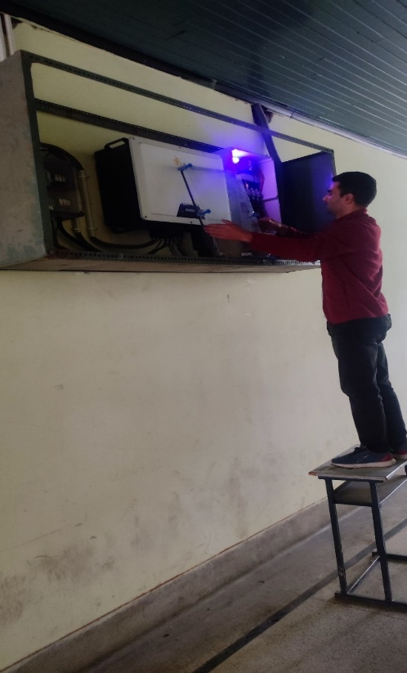

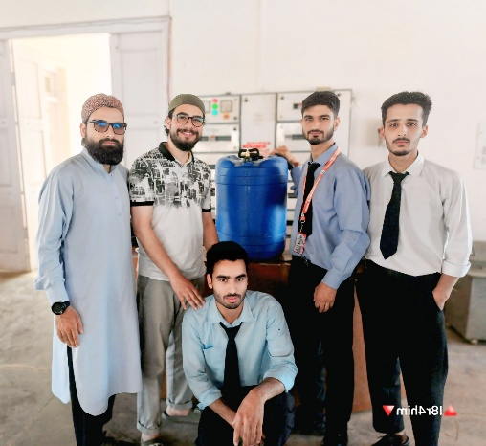
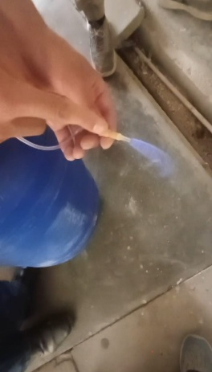
- Small Biogas Plant Project by Electrical Engineering Students (June 2025)
Sixth-semester Electrical Engineering students completed a small biogas plant project under the supervision of Ms. Masrat Mehraj. This project demonstrates innovation in renewable energy, aligning theoretical knowledge with practical applications in sustainable technology.

- Research Publication on Handwritten Urdu Text Recognition (July 2025)
Dr. Aejaz Farooq, along with co-authors, published a research paper titled "Towards automatic efficient recognition of multiresolution offline handwritten Urdu text using Swin Transformers" in the International Journal on Document Analysis and Recognition (IJDAR). This work advances document analysis through innovative use of Swin Transformers, contributing to the field of AI-driven text recognition.
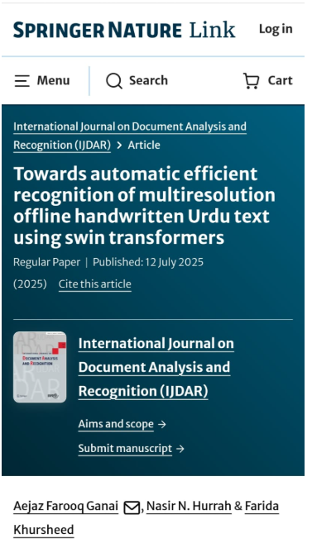

- Establishment of Hydraulics Lab (April 2025)
Faculty and technical staff from multiple engineering departments (Civil, Mechanical, Automobile, and Electrical) collaborated to establish a Hydraulics Lab, installing advanced hydraulic equipment to enhance hands-on learning in fluid mechanics and hydraulic systems.
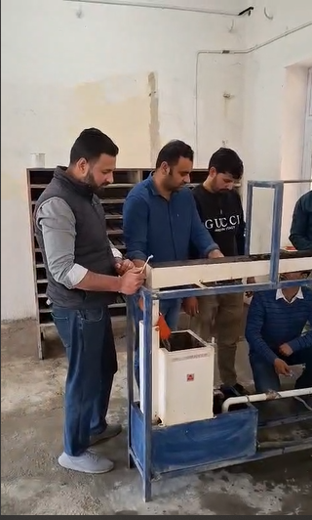
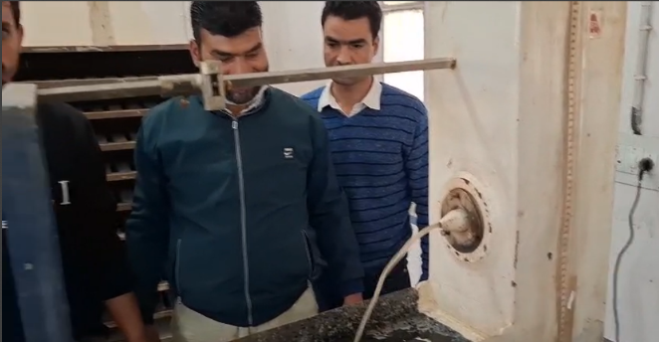

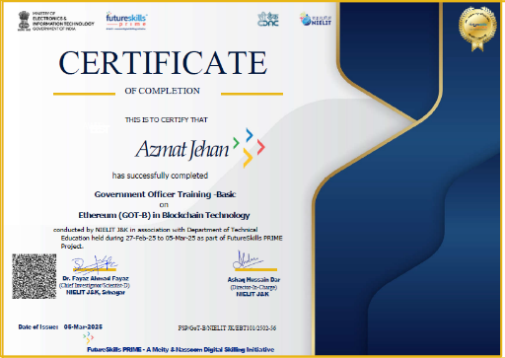
- AI and Generative AI Integration in Training (January 2025, March 2025)
Faculty members completed training programs on ChatGPT, Generative AI, and AI for Digital Transformation, equipping them to integrate cutting-edge AI technologies into academic frameworks and provide students with guidance on modern digital tools.
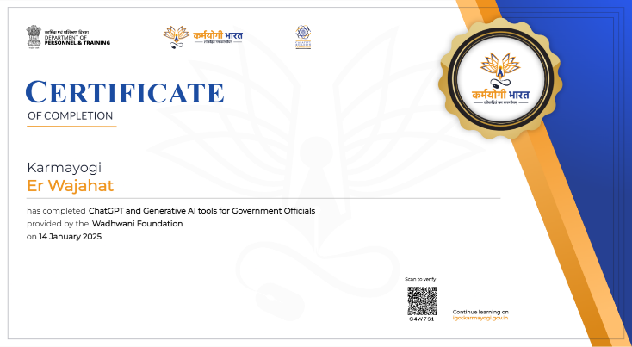
Best Practices
These are established methods or processes that demonstrate high standards in education, administration, or community engagement, ensuring efficiency, fairness, and quality.
- Smooth Conduct of Examinations.
KGP Srinagar consistently hosted major examinations such as JKSSB Screen Technician/Supervisor (February 2025), JKPSC KAS Preliminary (February 2025), JK BOPEE B.Sc. Nursing/Technology (April 2025), SKAUST UET-2024 (June 2025), and JKSSB Constable exams (December 2024). These were conducted with meticulous planning, adherence to protocols, and efficient coordination, ensuring a fair and organized process.
- Comprehensive Support for Student Registration.
The college implemented a robust support system for 1st-semester and lateral entry students to assist with JKBOTE registration and ABC ID creation, providing personalized guidance to ensure a seamless transition into academic life.
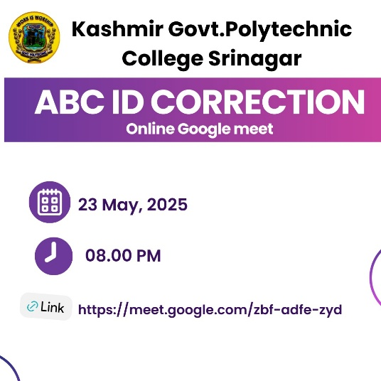

- Material Verification under Centrally Sponsored Scheme (CSS)
Expert faculty conducted thorough verification of materials procured under the CSS at various district polytechnics, ensuring quality, quantity, and compliance with specifications, reflecting a commitment to transparency and accountability.

- Faculty Development and Continuous Learning (Multiple Months)
Faculty members completed advanced training programs in Cybersecurity (February 2025, November 2024), Blockchain Technology (March 2025), Electronics Waste Management (June 2025), and Free ICT Tools (December 2024). These efforts ensure educators remain updated with industry trends, enhancing teaching quality.
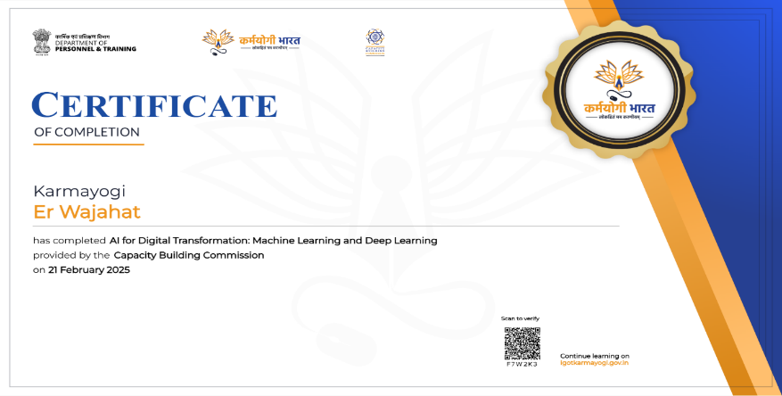

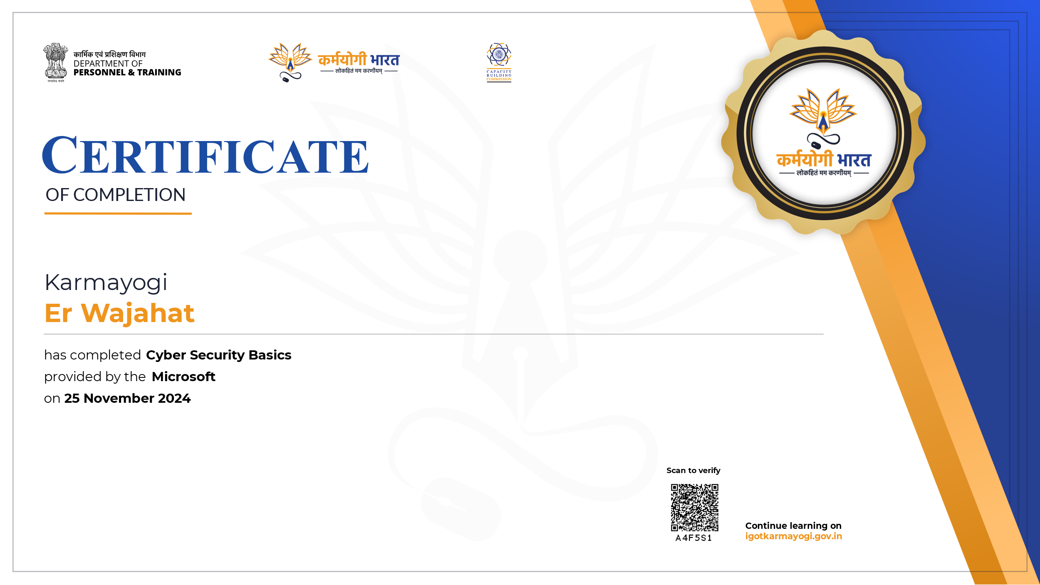

- Academic Excellence and Syllabus Completion (June 2025)
The college achieved 100% syllabus completion for 2nd and 4th semesters (MJ25 session) and successfully conducted practical and sessional examinations, reflecting a commitment to timely and comprehensive education delivery.
Unique Initiatives
These are distinctive programs or activities that set KGP Srinagar apart, often involving community engagement, industry collaboration, or tailored educational efforts.
- Kashmir Govt. Polytechnic College, Srinagar, Pioneers Solar Energy Initiative
The Electrical Engineering Department of this Institution has taken a significant stride towards sustainable energy by successfully connecting its computer lab to a 20KW off-grid solar power plant. By harnessing the power of the sun, the department aims to minimize its carbon footprint and contribute to a greener future. This solar power plant serves as a testament to the college's commitment to environmental sustainability and energy efficiency.
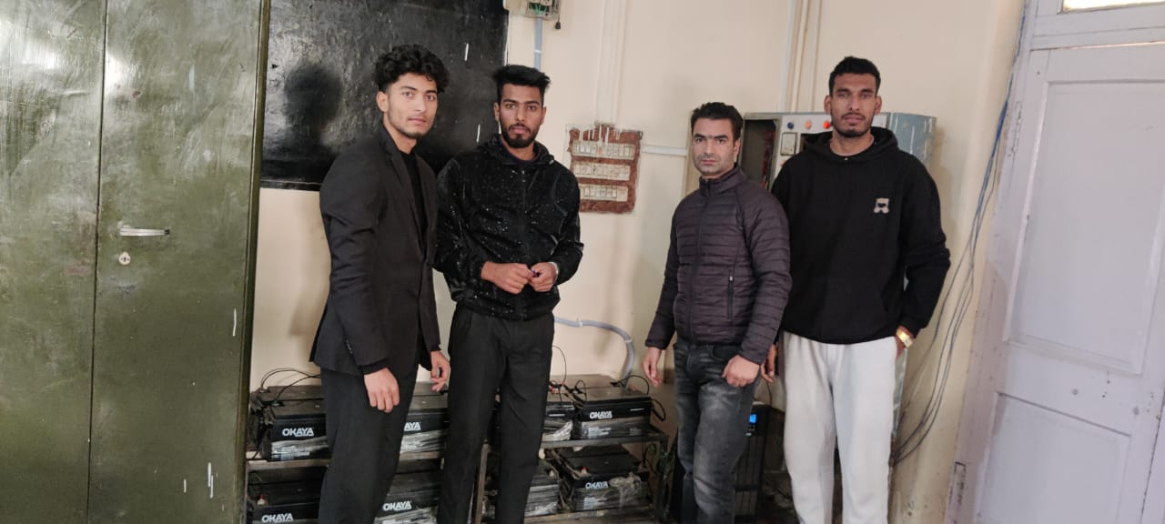

- Mission YUVA Engagement
KGP Srinagar actively participated in the Mission YUVA (Yuva Udyami Vikas Abhiyan) initiative, including a capacity-building program (October 2024), testing of the Baseline Survey Application (December 2024), and an Entrepreneurship Mela at Kashmir Haat (June 2025). Over 450 students registered on the Mission YUVA app, and two faculty members were selected as resource persons, fostering entrepreneurship and skill development among youth.
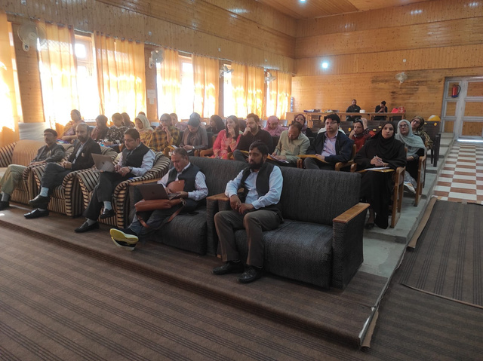
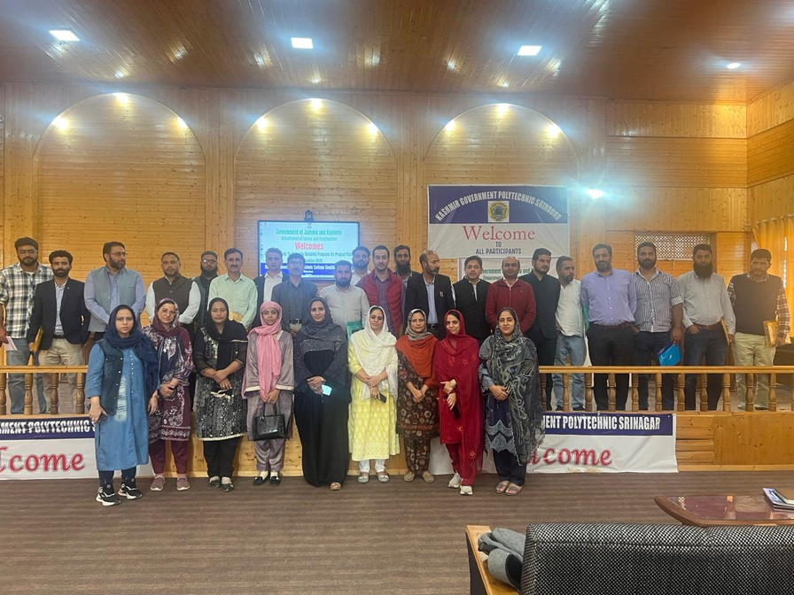
- Industry Visits for Practical Exposure (Multiple Months)
The college organized numerous industrial visits to bridge the gap between theory and practice, including:
- Mechanical Engineering students to iFACTORY LAB, IUST Pulwama (July 2025) and SKIMS Soura
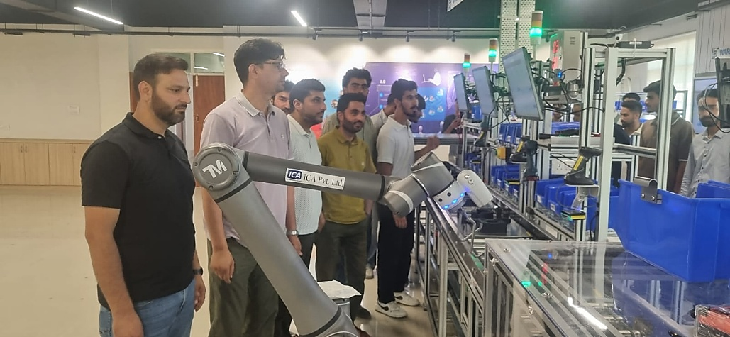

- Electrical Engineering students to Lower Jhelum Power Plant (July 2025) and USHP II Kangan (November 2024).

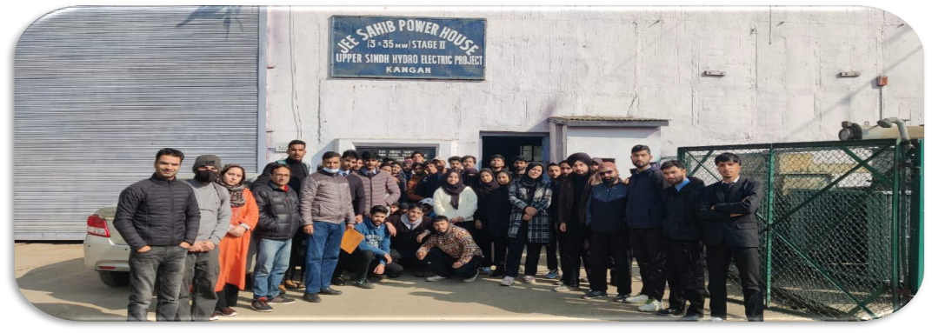

- Civil Engineering students to Trumboo Cement Industries (November 2024), RRL Rajbagh (December 2024), and Nowgam Railway Station (December 2024).
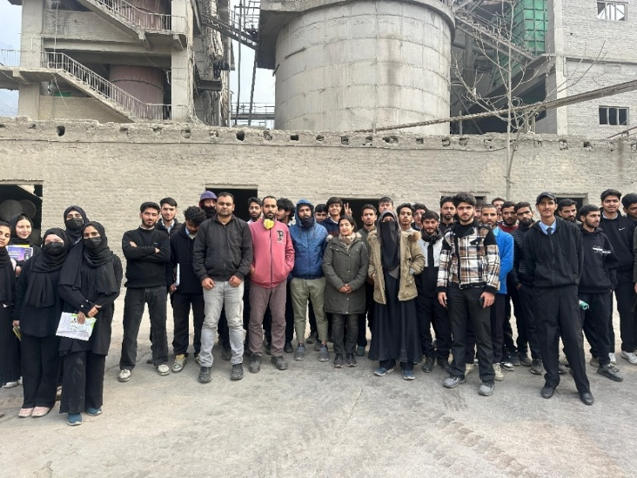
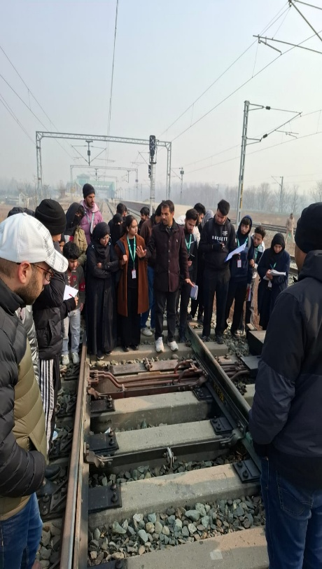

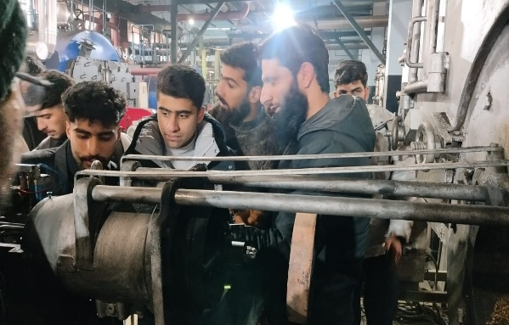

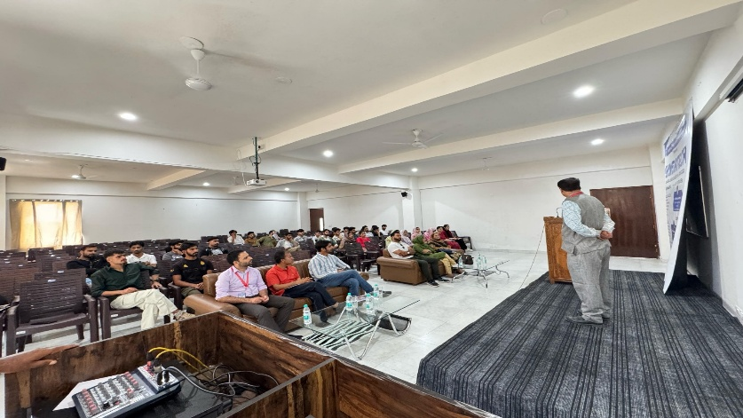

- Computer Engineering students to KCET (June 2025).

- Collaboration with Consumer Court.
Faculty experts provided technical consultation to the Consumer Court, preparing detailed reports to resolve disputes related to product quality and consumer grievances, demonstrating a unique contribution to judicial processes.
- Sexual Harassment Prevention Week
The college observed a week-long program (February 10-16, 2025) to reinforce its zero-tolerance policy towards harassment, educating the community on prevention and reporting, showcasing a commitment to a safe and inclusive environment.
- Menstrual Hygiene Session
KGP Srinagar hosted sessions on May 16 and 23, 2025, for female students and faculty to promote awareness about menstrual hygiene, fostering health education and gender-sensitive initiatives.
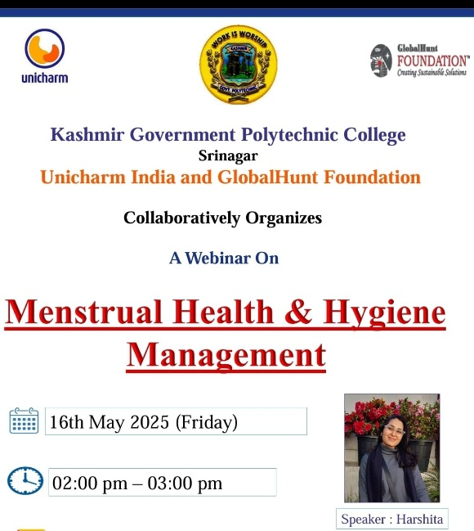

- Kashmir Government Polytechnic College Srinagar, Participates in AICTE x Apna's Campusinc 2025.
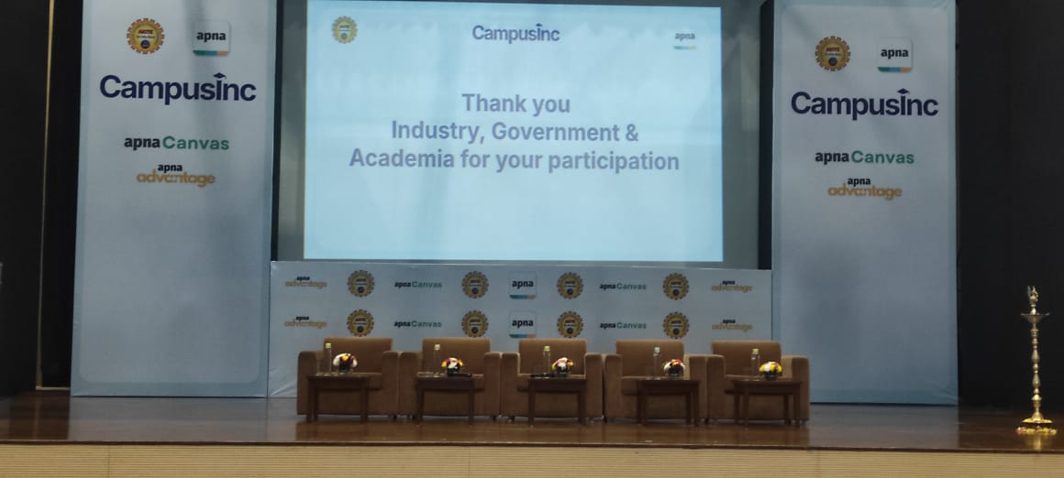

- Community Development through Polytechnics (CDTP) Program.
The CDTP certificate distribution ceremony at extension centers in Bemina empowered local communities through skill development, reflecting the college’s commitment to socio-economic development.

- Kashmir Govt. Polytechnic College, Srinagar, Empowers Future Tech Entrepreneurs by Partnering with JKEDI.
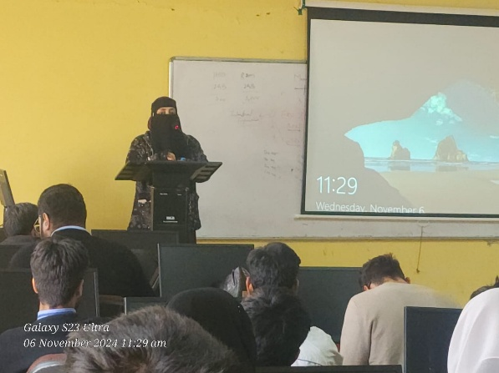

- Yuva Doot Program (May 2025)
The college hosted the Yuva Doot Program with dignitaries, promoting youth engagement and leadership, a unique initiative to inspire and empower students.
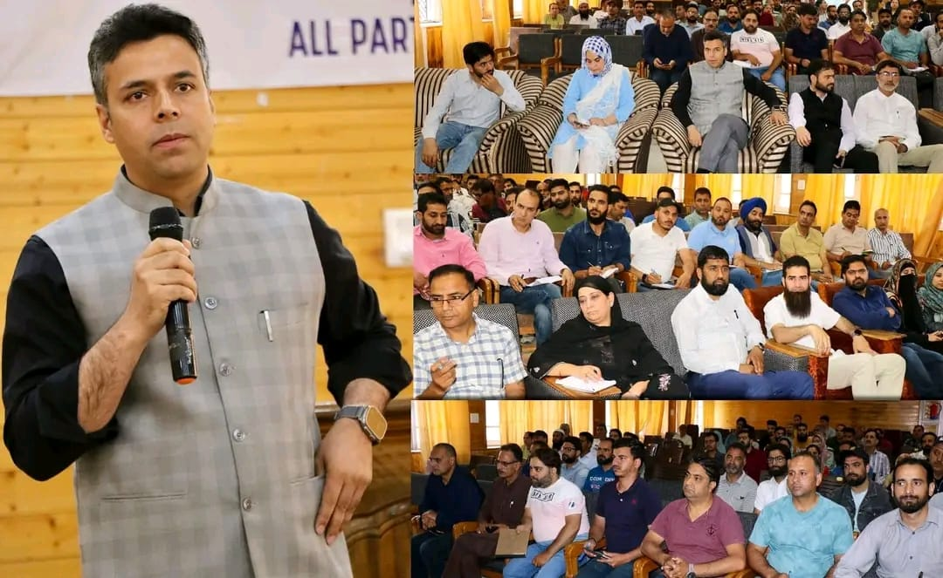

- Training for Geology and Mining Department Employees (March 2025)
The college conducted a tailored training program for employees of the Geology and Mining Department, focusing on computer literacy, MS Office, and AI integration, enhancing digital capabilities in a specialized sector.
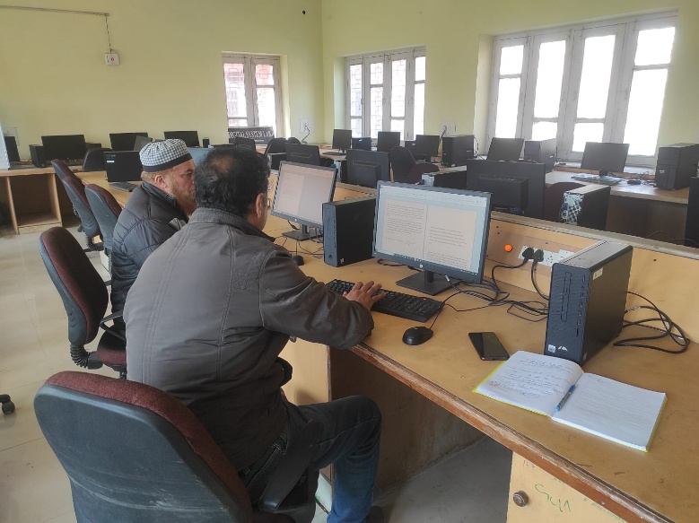

- Seminars on Entrepreneurship.

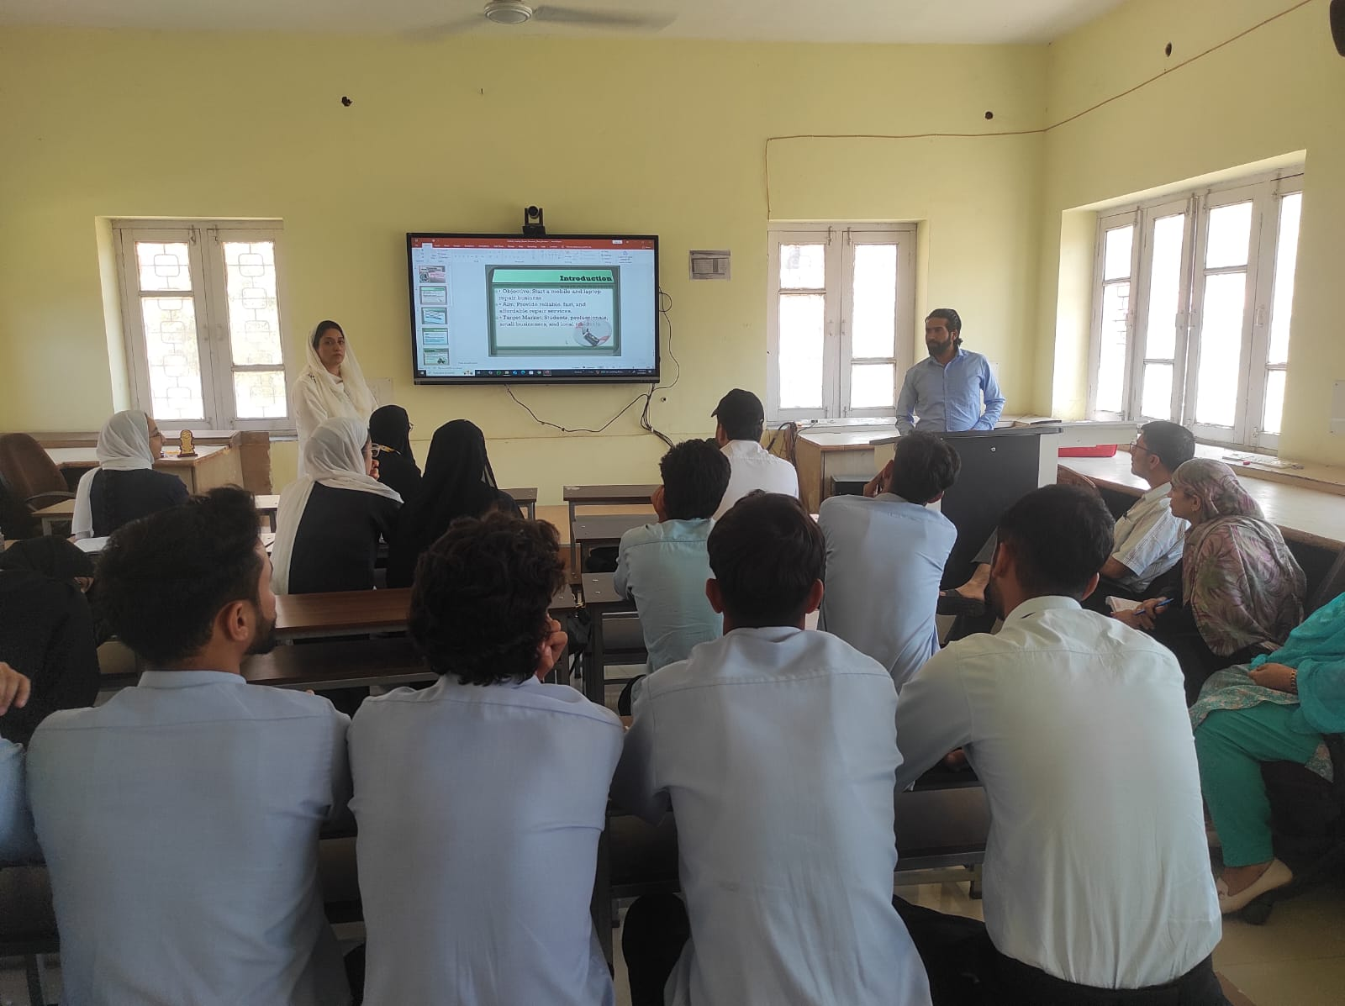

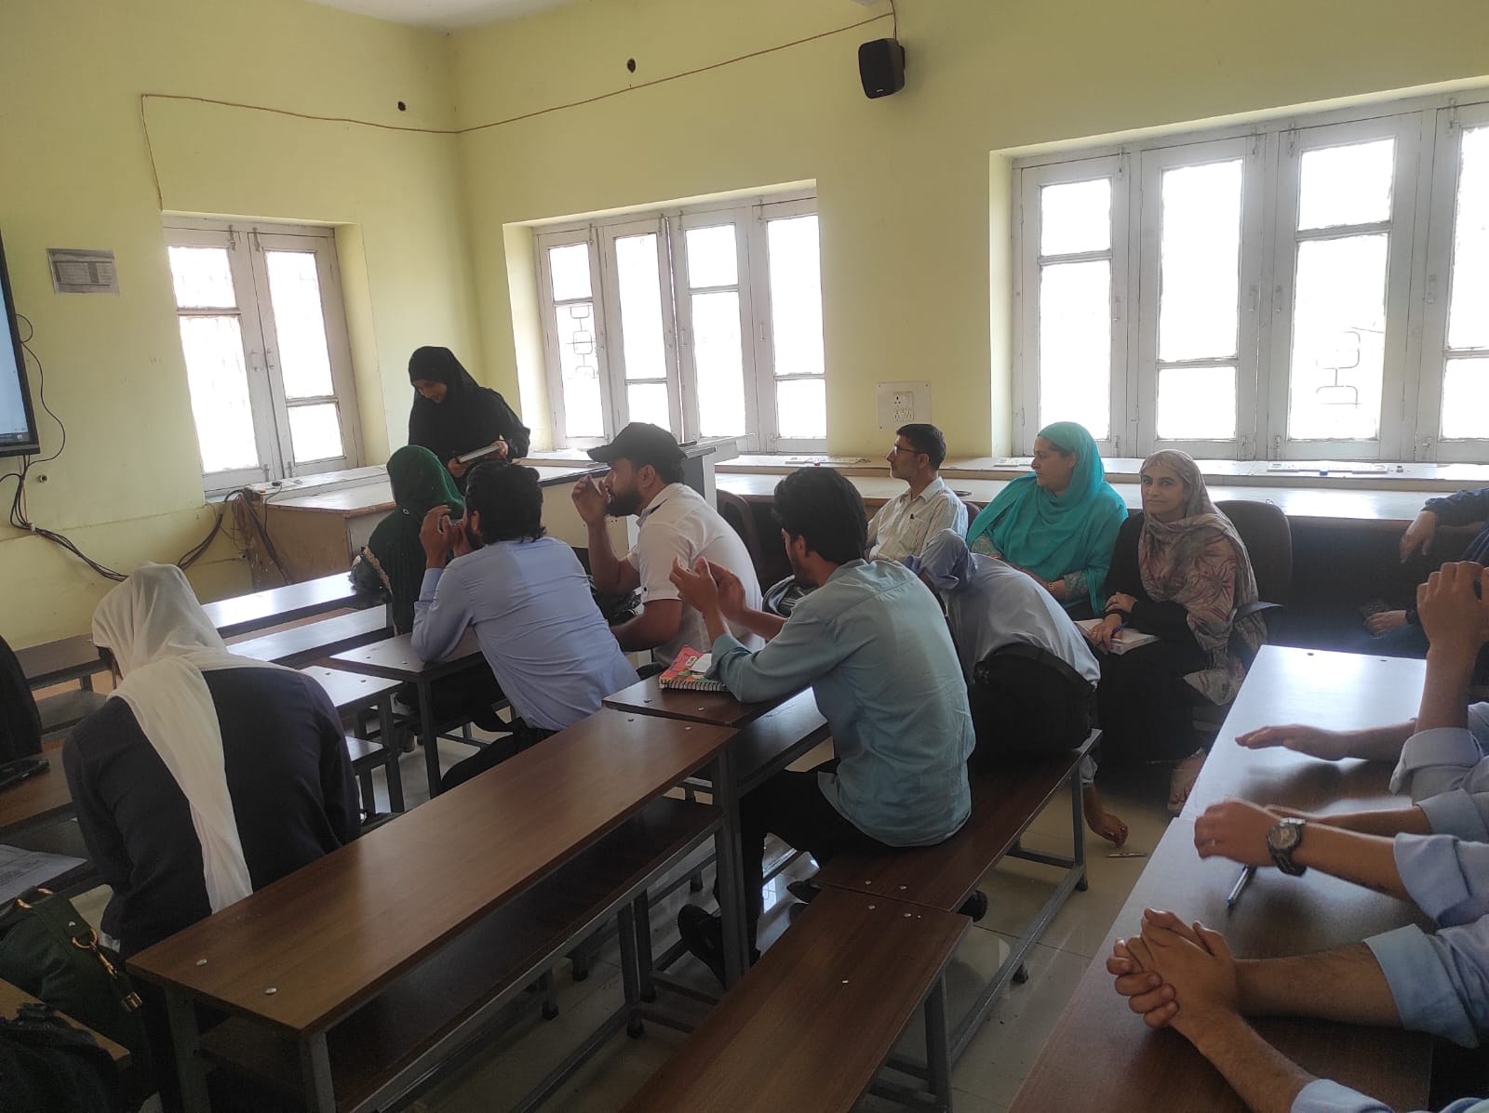

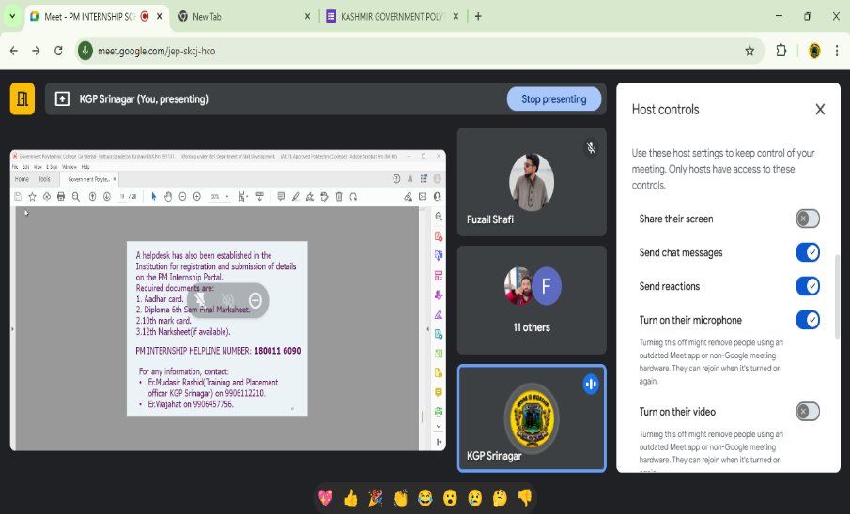
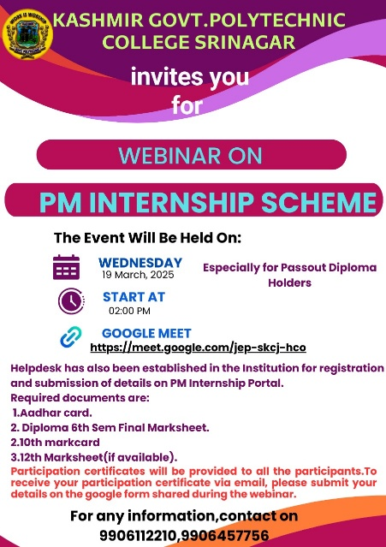
- Kashmir Government Polytechnic College Srinagar hosts webinar on PM Internship Scheme on 19-March-2025.

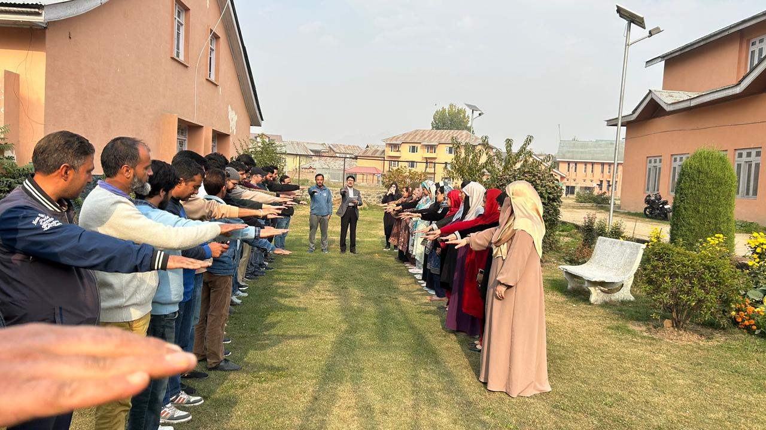
- Integrity Pledge Reinforces Commitment to Ethical Governance at Kashmir Government Polytechnic College Srinagar.

